# HP Printers

## Product Families

| **Product Family** | **Product Model** |
| --- | --- |
| **Home Printers (basic printing solutions) - 14 products** | |
| DeskJet | 2755e, 4155e, 3755 |
| ENVY | 6055e, 6455e, Inspire 7255e, Inspire 7955e |
| Smart Tank | 6001, 7001, 7301 |
| OfficeJet Pro | 8025e, 8035e, 9015e, 9025e |
| **Home Office & Business Printers (for small businesses) - 33 products** | |
| LaserJet Pro | 3001dw, 3001dwe, 3101fdw, 3101fdwe  4001dw, 4001dwe, 4101fdw, 4101fdwe  M110w, M110we, M140w, M140we  M209dw, M209dwe, M234sdw, M234sdwe |
| Color LaserJet Pro | M255DW, M283FDW, M454DW, M479FDW |
| LaserJet Tank | 2504DW, 2604SDW, Smart Tank 7301 |
| LaserJet Enterprise | M406dn, M430f |
| Color LaserJet Enterprise | M455dn, MFP M480f |
| **Enterprise Printers** | |
| Color LaserJet Enterprise | M455, M555dn, M653dn, M856dn  MFP M430, MFP M480, MFP M528dn, MFP M578dn, MFP M681dh, MFP M776dn  Flow MFP M682z, Flow MFP M880z |
| **Large-format Printers & Plotters (industry scale, large-scale manufacturing)** | |
| HP DesignJet plotters  HP PageWide XL printers  HP Latex printers  HP Stitch printers | |

## Additional products / services:

### HP+

* + “[HP+ Business](https://www.hp.com/us-en/printers/hp-plus.html?jumpid=ps_us_ga_mk_se_16749_awa_x_x&gclid=Cj0KCQjwz6ShBhCMARIsAH9A0qVAEzVlM_MsGy6i29QaKwdph2cLPAqL4Nhr7y0CIGIPE2aXxZocmfUaAgFGEALw_wcB&gclsrc=aw.ds)” is a smart printing system
  + Designed mainly for personal customers
  + It is kind of like AppleCare for Apple products
  + Available for some product families
    - DeskJet
    - ENVY
    - OfficeJet Pro
    - LaserJet
  + Business Insights
    - Potentially targeting customers with lower refresh rate. Incentivizing them to purchase a more expensive model, in exchange for better maintenance on their current printer and keeping them for longer

### Cartridges & Paper

#### HP [“Instant Ink”](https://www.hp.com/us-en/printers/instant-ink.html)

* + - A monthly ink or toner delivery subscription service
    - 5 different plans for ink or toner
      * Monthly price varies based on the plan
    - Add-on to Instant Ink: [Paper](https://www.hpsmart.com/us/en/paper-subscription) (5 different paper plans)
      * Light (10 sheets/month)
      * Occasional (50)
      * Medium (100)
      * Frequent (300)
      * Business (700)
    - Business Insight:
      * 7 columns are data from Instant Ink
      * Media targeting - customer segmentation - frequent users who have not subscribed to Instant Ink service (relevant variable: subscription_state, unsubscribe_date)

#### Paper Products

* + - Photo Papers
    - Business Papers
    - Home & Office Papers

### Managed Print Services

* + HP [Managed Print Services](https://www.hp.com/us-en/services/managed-print-services.html) is a new approach to secure, flexible, and manageable print solutions in the hybrid work environment
  + Designed for business customers
  + Business Insight:
    - Media target customers identified as small businesses. Recommend them this service
    - Relevant variable: user_sub_environment, Printer.Total

# Market Analysis

What is the printer product market like? Where does HP stand in the market? How does HP compare with other firms?

## Snapshot

* Largest market: North America
* Growth 4.95% - 6% through 2028
* Size: $9.7 billion
* Major players (moderately fragmented):
  + **HP** (24.5% of market in 2021, 19.7% in 2016)
  + Canon (17.7%)
  + Brother (10.7%)
  + EPSON (9.9%)
* Statista reports 94.4 million printers were shipped in 2020.
* Global revenue in 2021 topped $10.78 billion
* Hot industry: 3D printing

## Overview

* The industry is expected to grow steadily at 4.95% annual rate due to sustained demand from mobile printing, color printing, packaging printing, and cloud computing and software.
* Multi-functional printers further augment the market growth among individual users and small businesses.
* Relatively high ink cost is still a primary concern, making firms slower in switching to digital printing.

<https://www.tonerbuzz.com/blog/printer-market/>

<https://www.mordorintelligence.com/industry-reports/printer-market>

<https://www.thebusinessresearchcompany.com/report/printer-global-market-report>

# 

# HP Strategy

HP uses differentiating targeting strategy to provide customized products and services to customers. [10k report](https://s2.q4cdn.com/602190090/files/doc_financials/2022/ar/hp-fy2022-10-k.pdf)

HP has three reportable segments:

1. Personal Systems
2. **Printing**
3. Corporate Investment

Within Printing, HP’s **global business capabilities** are:

* Office Printing Solutions
* Home Printing Solutions
* Graphics Solutions
* 3D Printing and Digital Manufacturing

Printing groups the global business capabilities into the following **business units** when reporting business performance:

1. Commercial
2. Consumer
3. Supplies

## Strategy Snapshot

**Competitors:**

* Canon
* Lexmark International
* Xerox
* Epson
* Richo
* Brother
* Independent suppliers (offer non-original supplies)

**Targeted customers:**

* People aged 14-54 who have middle to upper-middle income and shop at a variety of retailers, online and in-store, from department and specialty stores to mass merchants.

**HP segments their targeted customers by:**

* Age
* Gender
* Income
* Consciousness / User case
  + Home users
  + Small and Medium-sized businesses (SMBs)
  + Large Enterprises
  + Graphic Arts and Design Professionals
  + Education and Government

## HP’s Marketing Strategy & Activities - “360 Branding”

* HP runs advertising campaigns **across a variety of platforms** (billboards, TV, prints, digital, social media, events, partnerships, etc.).
  + Facebook: 4.68M followers
  + Twitter: 1.1M followers
  + Instagram: 1.3M followers
  + YouTube: 244k followers
  + LinkedIn: 5.2M followers
* **Network Retail partners:**
  + Amazon
  + BestBuy
  + Staples
  + Office Depot
  + Walmart
* **Content Marketing** (Create authentic promotional content, usually with celebrities, influencers, etc.)
  + #BendTheRules
    - Award-winning campaign to promote Pavilion x360 laptop
    - Collaborated with meghan trainor to produce a [music video](https://www.youtube.com/watch?v=Bf7keYJNSlM) and social media stars on the campaign
  + “[Wolf Campaign](https://www.youtube.com/results?search_query=hp+the+wolf+campaign+)”
    - Promotion of HP Secure printers with Christian Slater for the Wolf campaign
  + “Keep Reinventing” campaign
    - Promotion tied with the release of the movie Star Wars: The Force Awakens
* Offers [exchange programs](https://h41201.www4.hp.com/WMCF.Web/us/en/landing/) to trade in old products for fresh ones
* As promotional activities, some services within a period of time are provided free. Periodic discounts on products are announced
  + **HP Discount Programs**
    - Education Store - discounts for teachers and students
    - Frontline Heroes Store - discounts for military, healthcare, first responders
    - Business Club - small business pricing and financing
* [One Voice](http://www.hp.com/hpinfo/execteam/bios/winkler_ana_article.pdf), a marketing initiative from HP back in 2004, aims to reinforce the company’s position as a one-stop shop for all software and hardware requirements.

## Operations

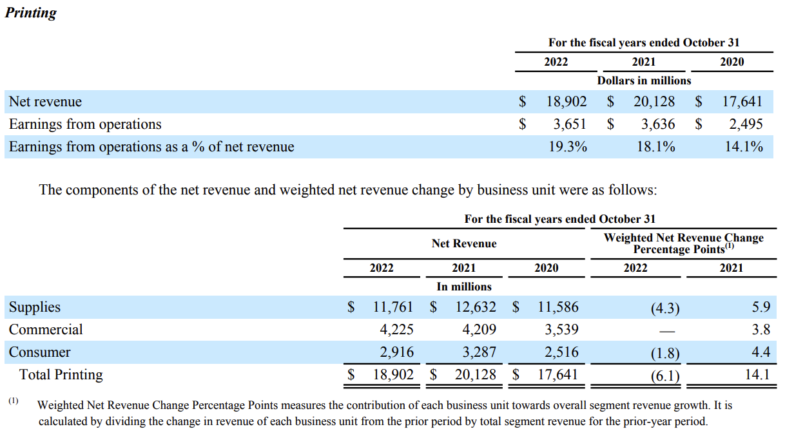

**Supplies** accounted for about **62%** of net revenue in the Printing segment in 2022.

# Marketing Intervention

* Customer Journey from 401
  + What are some specific intervention at each stage of the process
* Use Jinny’s data in tableau
  + BP and PP fields
  + Any correlations between BP/PP and other columns
    - PP vs. income
    - PP vs. education
    - PP vs. number of children
  + Other EDA

Household income

1 = Less than $15,000

2 = $15,000 - $19,999

3 = $20,000 - $29,999

4 = $30,000 - $39,999

5 = $40,000 - $49,999

6 = $50,000 - $74,999

7 = $75,000 - $99,999

8 = $100,000 - $124,999

9 = Greater than $124,999

## Customer Journey & Intervention

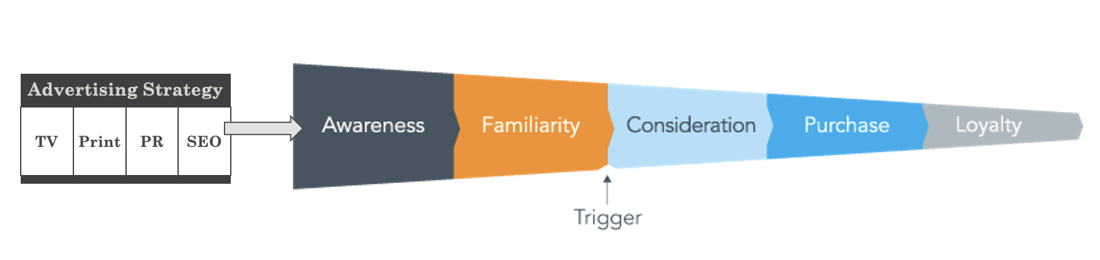

From Ashwin’s course and this [link](https://blog.sightly.com/sightlyinsights/full-funnel-solution)

* Awareness

HP already does a pretty good job at content marketing (collab with celebrities to create authentic promotional content). These campaigns are probably costly. In the current economic state, HP might need to switch to more low cost marketing channels (also mentioned in HP’s 2022 10K report)

* + They should look into social media marketing. Social media marketing is proving to be more important, and it also provides companies with [first-party data](https://blog.hubspot.com/service/first-party-data?hubs_content=blog.hubspot.com%2Fservice%2Ffirst-party-data&hubs_content-cta=What%20is%20First%20Party%20Data%3F).
    - Social media chat conversations
    - Social media comments and likes
    - Click through rate from social media product posts
  + HP has a solid follower base on many major platforms. They could pour more effort into promotional campaigns on their social media accounts to raise awareness and further grow their follower base.
    - Facebook: 4.68M followers
    - Twitter: 1.1M followers
    - Instagram: 1.3M followers
    - YouTube: 244k followers
    - LinkedIn: 5.2M followers
  + Put ads to showcase HP’s social media accounts.
    - Especially video advertisement content!
  + HP products are well-known. Maybe shift towards promoting supplies and services, such as Instant Ink.
    - I have a HP printer at home, but I didn’t know there’s an ink subscription service.
  + Promote HP+
* Familiarity
  + Once customers hear or see enough of the brand, they become familiar with it.
  + Principle of Synergy
    - Allocating ad spend and resources to less effective medium, if the medium exhibits synergy with other mediums
    - building a catalytic effect of synergy

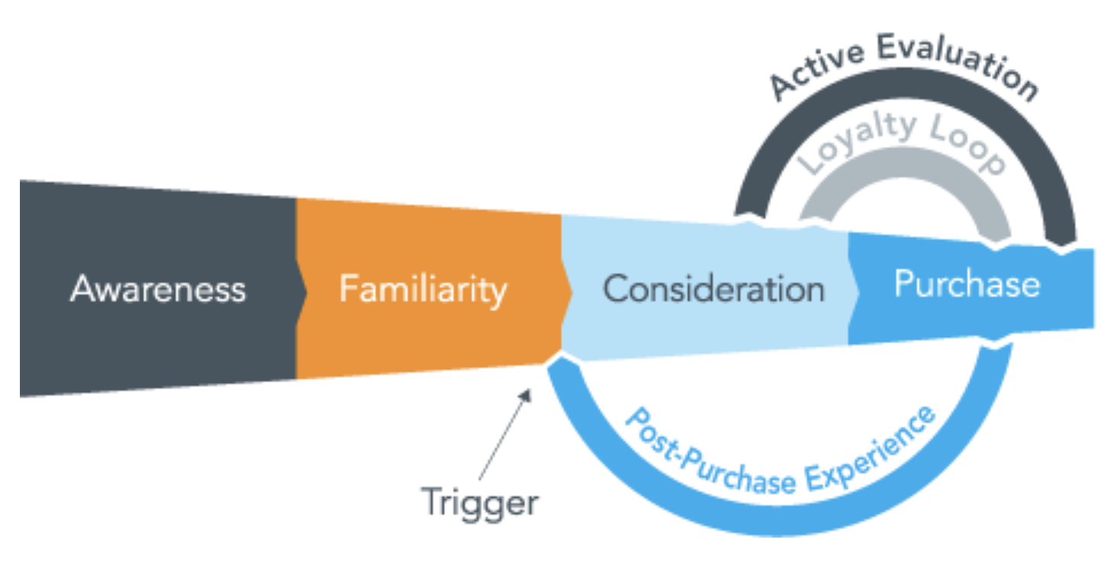

**Trigger comes in!** Can be anything, including another piece of advertisement from the awareness/familiarity

* Consideration
  + Consideration is the immediate step before making a purchase. It also feeds active evaluation into purchases.
    - Online chat
    - Improve post-purchase customer service
    - Improve key feature usability
      * HP+
      * Instant Ink
      * Managed Print Services
* Purchase
  + Post-purchase experience is fed back into the Consideration Phase
* Loyalty
  + Subscription, HP+

# 

# Slides Outline & Annotation

## Intro

* Analysis Outcome!
  + Numbers!

## Background & Problem (cut-down)

* Background
  + HP company
  + Products
  + competitors
  + market growth
  + Reason for success (**based on research**)
    - So far, excellent customer segmentation and targeting
    - Profitable area of Printing segment (from 10K): services
* Define the problem
  + Google removes 3rd Party data. HP needs to adapt to a cookie-less future

HP has three reporting areas: Personal Systems, Printing, and Corporate Investment. In the Printing area, HP’s business capabilities include Home Printing Solutions, Office Printing Solutions, Graphics Solutions, and 3D Printing and Digital Manufacturing. HP groups its printing business capabilities into the following three business units: Commercial, Consumer, and Supplies.

HP printers are categorized into various product families such as DeskJet, ENVY, OfficeJet, and LaserJet. Each family has substantial product depth, usually containing multiple product models.

In the printing product industry, HP takes up a large portion of market share (24.5% in terms of printers shipment in 2021), in front of its main competitors (Canon, Lexmark, Xerox, Epson, Rich, Brother, and independent suppliers). HP went through a period of strong growth over the past several years, where its market share was at 19.7% in 2016.

The reason for HP’s recent success can be attributed to its excellent customer segmentation strategy, where HP targets different types of customers differently. Separately, the main source of revenue in HP’s Printing business came from Supplies, which took up about 62% of net revenue in 2022, overshadowing the other two business units: Consumer and Commercial.



In January 2020, Google announced that it would remove 3rd party cookies from Chrome. Many companies including HP use third party data from cookies to drive customer marketing initiatives. This is a significant change to the source of HP’s successful customer segmentation. Without sufficient and detailed customer data, HP could lose out on maintaining its growing customer base and, consequently, its edge in the market.

As a result, HP has to adapt in a cookie-less future. The company has chosen to leverage its first-party data gathered over the years.

Additionally, in HP’s 2022 10K report, HP described that they estimate sales and marketing program incentives based on various factors. And were these assumptions to change or fail, HP’s operations, cash flows, and financial condition could be adversely affected.

“We also estimate sales and marketing program incentives based on a number of factors including historical experience, expected customer behavior and market conditions. These estimates and assumptions are subject to significant uncertainties, some of which are beyond our control. Should any of these estimates and assumptions change or prove to have been incorrect, it could adversely affect our results of operations, cash flows and financial condition.”

## Goal & Plan

* Goal:
  + Maintain excellent customer segmentation with 1st party data
  + Maximizing revenue during unpredictable economic conditions
* Plan:
  + First - Understand existing customers - **Customer Segmentation**
  + Then - Understand drivers of repurchase - **Repurchase Analysis**
  + Leverage customer purchase journey
    - Awareness -> familiarity -> consideration -> purchase <-> loyalty
    - **Customer Segmentation** allows us: Draw new customers into consideration and maximize purchase rate
    - **Repurchase Analysis** allows us: sustain the loyalty loop

The goal of our analysis is two-fold. First, we aim to maintain accurate and appropriate customer segmentation using provided first-party data. Second, we want to derive factors that drive customer repurchase, which can be then used to target existing customers and maximize revenue.

To achieve these goals, we have laid out the following three-step plan:

First, we want to understand the characteristics of HP’s existing customers and classify them into segments based on their prominent characteristics. This helps us lay the foundation for further analyzing consumer behaviors such as repurchase intention.

Second, based on the classification, we look into each customer segment to exploit their repurchase perspectives and sift out key factors that influence their decision to repurchase HP products. This step provides us with actionable insights that can be applied to a customer’s purchase journey.

At the last step, we implement the insights generated from the analysis to the purchase journey of HP’s potential and existing customers. By integrating our background research and analysis, we can provide a range of concrete marketing recommendations that are appropriate for HP’s printing business and its current economic outlook.

## Data, Preprocessing, Assumptions, EDA

* Data intro
  + De-identified, partial, 1st-party data from HP
* Preprocessing
  + How did we handle NAs?
    - Approach 1:
      * [field]
      * [field]
    - Approach 2:
      * [field]
      * [field]
* Any assumptions we made
* EDA

We were provided with a massive de-identified dataset from Z by HP. It is a partial dataset to HP’s first-party customer database. The dataset contains 2,169,286 rows of product-level data that can be aggregated to customer level. It has 75 fields including basic customer and product info (e.g. customer id, product serial number), customer demographics info (e.g. age, gender), customer interest and behavioral info (e.g. customer purchasing propensity of various products), and HP product usage info (e.g. total ink used, average monthly pages printed).

With its size, the dataset also comes with necessary preprocessing needs. Specifically, we applied several techniques to address missing values in the data: [XXX].

We also made a few necessary assumptions to progress our analysis: [XXX]

To get a better sense of the underlying data, we explored and visualized several key fields:

## 4-Tier Customer Segmentation (Jinny’s)

* Recommendation / Summary (承接目前结构)

[Annotation]

## Customer Repurchase (Ian’s)

[Annotation]

## Recommendation

* Intervention steps along the customer purchase journey
  + At awareness & familiarity
    - Social media marketing, briefly mention HP’s current strategy **based on** **research**
    - Marketing synergy
      * Mention broader impact of macroeconomic factors
  + At consideration:
    - Targeting potential customers based on **segmentation**
    - Recommend new products to existing customers based on **repurchase** **analysis**
  + At purchase & loyalty
    - Promotion subscription services and HP smart or management services
      * Instant Ink
      * HP+
      * Managed Print Services

Areas:

* Usage
  + Promote Instant Ink and paper plan.
* Laptop & Printer bundle
  + Adjust website’s display of recommended products list. Make HP printers more visible.
* Targeting individual customers, driving new customers into Consideration phase
  + Social media ads and content marketing campaigns
* Existing customers repurchase & loyalty
  + Promoting HP+ services to boost customer post-purchase experience, and drive up profit margin from HP+ compatible, high-ticket products.
* Enterprise customers loyalty
  + Promote HP Managed Print Services

Awareness & Familiarity - HP has been doing a pretty good job at the first step of the customer purchase journey. HP runs advertising campaigns across multiple platforms. In recent years, HP achieved successful results from several content marketing campaigns such as “#BendTheRules” for the Pavilion x360 laptop, “Wolf Campaign” for HP Secure printers, and the recent “Keep Reinventing” HP logo campaign. It has a sizable social media presence, which is a fast-growing, modern, and effective way for companies to promote products and attract businesses. HP should continue to maintain its social media platform and grow its follower base. They should also consider running ads on social media platforms as a cost-effective way to boost brand awareness and familiarity among potential customers.

* LinkedIn: 5.2M followers
* Facebook: 4.68M followers
* Instagram: 1.3M followers
* Twitter: 1.1M followers
* YouTube: 244k followers

Consideration - This is the immediate step before customers make a purchase.

For new customers, HP should target potential customers with personalized media campaigns based on their segmented characteristics from the analysis. For example, if a new customer is identified to be similar with Tier D of the segmentation, HP marketing team should target the customer with [XXX] products as they are more likely to purchase this type of product.

For existing customers, HP should recommend new products to those who haven’t repurchased but are identified to be likely buyers based on their characteristics. While doing so, HP should also target these customers with campaigns about HP+, a convenient smart printing solution app service that comes free with pricer compatible models. Attracting more customers to purchasing and using HP+ compatible models could boost HP’s profit margin and long-term revenue stream.

Purchase & Loyalty Loop - for loyal customers and potential repurchasers, we recommend HP to focus their marketing efforts on subscription services such as Instant Ink and enterprise printing services such as (Managed Print Services). These add-on services provide additional value to HP’s long-term revenue stream. We expect Instant Ink to be particularly profitable if HP could increase the subscriber base substantially, given that the Supplies business unit consistently made up the majority of HP’s revenue in the Printing business over the years.

## Conclusion

* Our team

In conclusion, to successfully transition from using third-party data to first-party data, we believe [XXX] is the appropriate way for HP to segment customers and derive customer repurchase behaviors.

## Appendix